Statistical Inference Assignment Project Part 2

Francisco Mimica Porras

2/16/2021

# Overview

This report aims to analyze the ToothGrowth data in the R datasets package. Per the course project instructions, the following items should occur:

Load the ToothGrowth data and perform some basic exploratory data analyses Provide a basic summary of the data. Use confidence intervals and/or hypothesis tests to compare tooth growth by supp and dose (only use the techniques from class, even if thereâs other approaches worth considering). State your conclusions and the assumptions needed for your conclusions.`

# Analysis

# First we will load the necessary libraries.

library(ggplot2)

# Load ToothGrowth data

data("ToothGrowth")

# Display a summary of the data

summary(ToothGrowth)

## len supp dose   
## Min. : 4.20 OJ:30 Min. :0.500   
## 1st Qu.:13.07 VC:30 1st Qu.:0.500   
## Median :19.25 Median :1.000   
## Mean :18.81 Mean :1.167   
## 3rd Qu.:25.27 3rd Qu.:2.000   
## Max. :33.90 Max. :2.000

#Display the first few rows of data

head(ToothGrowth)

## len supp dose  
## 1 4.2 VC 0.5  
## 2 11.5 VC 0.5  
## 3 7.3 VC 0.5  
## 4 5.8 VC 0.5  
## 5 6.4 VC 0.5  
## 6 10.0 VC 0.5

##Unique Values

unique(ToothGrowth$len)

## [1] 4.2 11.5 7.3 5.8 6.4 10.0 11.2 5.2 7.0 16.5 15.2 17.3 22.5 13.6 14.5  
## [16] 18.8 15.5 23.6 18.5 33.9 25.5 26.4 32.5 26.7 21.5 23.3 29.5 17.6 9.7 8.2  
## [31] 9.4 19.7 20.0 25.2 25.8 21.2 27.3 22.4 24.5 24.8 30.9 29.4 23.0

unique(ToothGrowth$supp)

## [1] VC OJ  
## Levels: OJ VC

unique(ToothGrowth$dose)

## [1] 0.5 1.0 2.0

# Plots

# exploring the data.

## Convert dose to a factor

ToothGrowth$dose<-as.factor(ToothGrowth$dose)

## Plot tooth length (‘len’) vs. the dose amount (‘dose’), broken out by supplement delivery method (‘supp’)

ggplot(aes(x=dose, y=len), data=ToothGrowth) + geom_boxplot(aes(fill=dose)) + xlab("Dose Amount") + ylab("Tooth Length") + facet_grid(~ supp) + ggtitle("Tooth Length vs. Dose Amount \nby Delivery Method") +   
 theme(plot.title = element_text(lineheight=.8, face="bold"))

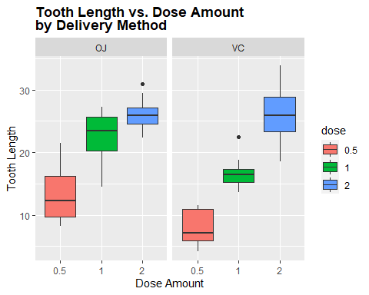

## Plot tooth length (‘len’) vs. supplement delivery method (‘supp’) broken out by the dose amount (‘dose’)

ggplot(aes(x=supp, y=len), data=ToothGrowth) + geom_boxplot(aes(fill=supp)) + xlab("Supplement Delivery") + ylab("Tooth Length") + facet_grid(~ dose) + ggtitle("Tooth Length vs. Delivery Method \nby Dose Amount") +   
 theme(plot.title = element_text(lineheight=.8, face="bold"))

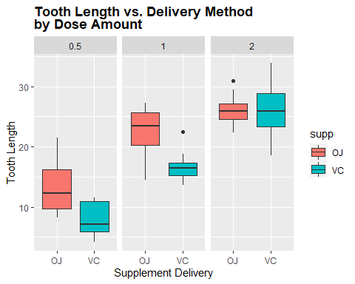

# Comparing tooth growth by supplement using a t-test.

# run t-test

t.test(len~supp,data=ToothGrowth)

##   
## Welch Two Sample t-test  
##   
## data: len by supp  
## t = 1.9153, df = 55.309, p-value = 0.06063  
## alternative hypothesis: true difference in means is not equal to 0  
## 95 percent confidence interval:  
## -0.1710156 7.5710156  
## sample estimates:  
## mean in group OJ mean in group VC   
## 20.66333 16.96333

### The p-value of this test was 0.06. Since the p-value is greater than 0.05 and the confidence interval of the test contains zero we can say that supplement types seems to have no impact on Tooth growth based on this test.

# Comparing tooth growth by dose, looking at the different pairs of dose values.

## Run t-test using dose amounts 0.5 and 1.0

ToothGrowth_sub <- subset(ToothGrowth, ToothGrowth$dose %in% c(1.0,0.5))  
t.test(len~dose,data=ToothGrowth_sub)

##   
## Welch Two Sample t-test  
##   
## data: len by dose  
## t = -6.4766, df = 37.986, p-value = 1.268e-07  
## alternative hypothesis: true difference in means is not equal to 0  
## 95 percent confidence interval:  
## -11.983781 -6.276219  
## sample estimates:  
## mean in group 0.5 mean in group 1   
## 10.605 19.735

## Run t-test using dose amounts 0.5 and 2.0

ToothGrowth_sub <- subset(ToothGrowth, ToothGrowth$dose %in% c(0.5,2.0))  
t.test(len~dose,data=ToothGrowth_sub)

##   
## Welch Two Sample t-test  
##   
## data: len by dose  
## t = -11.799, df = 36.883, p-value = 4.398e-14  
## alternative hypothesis: true difference in means is not equal to 0  
## 95 percent confidence interval:  
## -18.15617 -12.83383  
## sample estimates:  
## mean in group 0.5 mean in group 2   
## 10.605 26.100

## Run t-test using dose amounts 1.0 and 2.0

ToothGrowth_sub <- subset(ToothGrowth, ToothGrowth$dose %in% c(1.0,2.0))  
t.test(len~dose,data=ToothGrowth_sub)

##   
## Welch Two Sample t-test  
##   
## data: len by dose  
## t = -4.9005, df = 37.101, p-value = 1.906e-05  
## alternative hypothesis: true difference in means is not equal to 0  
## 95 percent confidence interval:  
## -8.996481 -3.733519  
## sample estimates:  
## mean in group 1 mean in group 2   
## 19.735 26.100

The p-value of each test was essentially zero and the confidence interval of each test does not cross over zero (0). We can assume that the average tooth length increases with an inceasing dose, and therefore the null hypothesis can be rejected.

# Conclusion

The t-test analysis from above, we can conclude that supplement delivery has no effect on tooth growth/length, however increased dosages do result in increased tooth length.